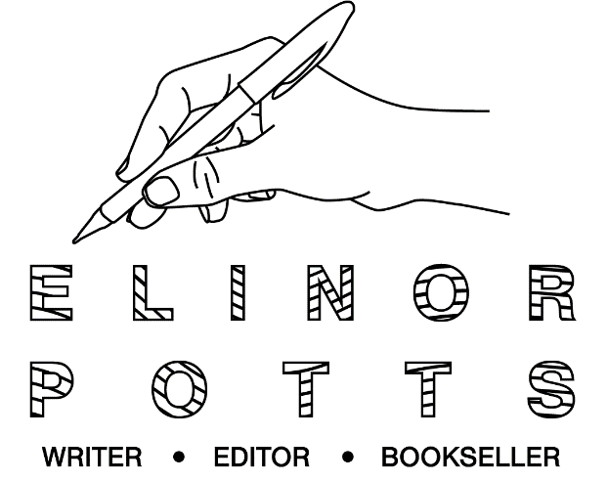

Creative Journalism Portfolio
www.elinorpotts.com

Not9to5 Blogs
- Setting Our Intentions, January 2020
- Making Creativity Work, January, 2020
- Prioritising Mental Health, February 2020
- Celebrating Flexible Work, February 2020
- Working and Being, March 2020
- Why Collaboration Matters, March 2020
- Connecting Creative Communities, March 2020
Freelance Commissions
- Strand Magazine
  - Interview with Saskia Vogel and Review of Permission - March, 2020
- UnderPinned Magazine
  - Book Review Feature, Alison Grade’s The Freelance Bible - March 2020
UnderPinned Magazine
Cultural Columns
- The Final Act, February, 2020
- Birthday Cake and Gratitude, February, 2020
- Steamy Season, February, 2020
- Cultural Mediators, January, 2020
- Sleep, January, 2020
- Cultural Intentions, January, 2020
- The Gifts of the Magi, December, 2019
- Cultural Legacies, December, 2019
- Cutural Retreats, December, 2019
- A Love of Letters, November, 2019
- Regarding the Pain of Artists, October, 2019
- Cutural Tribes, October, 2019
- Halloween, October, 2019
- Tricks and Treachery, October, 2019
- Prized Culture, September, 2019
- Word Games, September, 2019
- An Education, September, 2019
- A Treatise on Tote Bags, August, 2019
- What’s So Great About The Fringe? August, 2019
- Finding A Home In The Arts, August, 2019
- The Cultural Robot, July, 2019
- The Joy of Cultural Reviewing, June, 2019
- Indelible Women, July, 2019
- Sun, Sea and Stockholm City, June, 2019
- Cultural Nourishment, June, 2019
- Hacking High Arts, June, 2019
- Guilt-Free Pleasure, May, 2019
- Accessing Arts, May, 2019
- Reasons to be cheerful, May, 2019
- Outsider Arts, May, 2019
- Party Through the Panic, April, 2019
- Filthy and Furious Freelance Culture, April, 2019
- Culture To Ease Your Stress, March, 2019
- Unfashionably Great, March, 2019
- Schmalentines, February, 2019
- Resolutions Are Over, February, 2019

Theatre Reviews
- The Best Theatre 2018, December, 2018
- Review of True West at the Vaudeville, December, 2018
- A Very Very Very Dark Matter at the Bridge Theatre, November, 2018
- Macbeth at the Barbican, November, 2018
- Theatre Review: Stories at the National, November, 2018
- Review: Mrs Dalloway at the Arcola, October, 2018
- Review: Wise Children at the Old Vic, October, 2018
- Review: Wild Duck at the Almeida, October, 2018

Cool Brother
- Live Review: Fat White Family at Citadel Festival, July, 2018
- Hinds Band Review NB: This was published in the print edition of the magazine.

The Observer New Review
- Browse a Bookshop: St Ives Bookseller, March 18, 2018
- Browse a Bookshop: No Alibis, Belfast, March 11, 2018
- Browse a Bookshop: Simply Books, Bramhall, Cheshire, March 4, 2018
- Browse a Bookshop: Arthur Probsthain, Bloomsbury, London, February 25, 2018
- ‘They are strong and attractive’: Vespa Club Uganda, February 24, 2018
- Japanese Swimmers Dive Into Spring, March 3, 2018

The Times Magazine
- It’s Never Too Late to be a Stand-up Comedian, August 3, 2018
A Younger Theatre
- Review: Night Alive, Brockley Jack Theatre, May 2018,
- Review: Voices from the Deep, Paperclip Theatre, May 2018,
- Review: Mood Music, the Old Vic, April 2018,
- Review: Rush at Baron’s Court Theatre, April 2018,

The Indiependent
- 13 Songs to Soundtrack the Imminent Apocalypse: A Prophetic Vision of Post-Brexit Britain July 2016
- Live Review: Peace/Superfood MegaBand (Under the Guise of Radical Lasagne) // The Old Blue Last – 26.08.16 August 2016
- Let Them Eat Chaos: Kate Tempest, Album Review, October 2016

[Smiths] Magazine
- Shared Words with Nicola Barker, January 2018
- Hamlet in Hackney, March 2018
- Review: Jess Thom’s ‘Not I’ at the Battersea Arts Centre, March 2018
- [smiths] tries... The Goldsmiths Composers Collective (GCC), February 2018
- Review: The Suppliant Women at the Young Vic, December 2017
- Review: Notorious: The Famous Lauren Barri Holstein, December 2017
- Review: The Letters of Sylvia Plath 1940-1956, November 2017
- H(A)PPY by Nicola Barker: Reviewed, November 2017
- Chris Kraus: After Kathy Acker, London Review Bookshop, October 2017
- Vienna Festwochen: Slavoj Žižek ‘The Courage of Hopelessness’ at AK Wien Bildungszentrum, Vienna. 20/05/17
- Notes from Vienna, March 2017
- Mike McCormack in Conversation with Blake Morrison, February 2017
- 1984 The Play: A Review, September 2016
- Yours Ever Loving & The Frights: A Review, May 2016
- Boy: A Review, April 2016

Far Out Magazine
- Open'er Festival Preview, July 2014

